**Violet Crown Films  
Presents**

**A RAILYARD FILMS PRODUCTION**

**STARVING THE BEAST**

**A film by Steve Mims and Bill Banowsky**

95 minutes

**Official Selection**

2016 SXSW Film Festival – World Premiere

**FINAL PRESS NOTES**

**Publicity Contact**

Elizabeth Mims

Elizabeth@violetcrownfilms.com

**SYNOPSIS**

**Starving the Beast** examines the on-going power struggle on college campuses across the nation as political and market-oriented forces push to disrupt and reform America’s public universities. The film documents a philosophical shift that seeks to reframe public higher education as a ‘value proposition’ to be borne by the beneficiary of a college degree rather than as a ‘public good’ for society. Financial winners and losers emerge in a struggle poised to profoundly change public higher education. The film focuses on dramas playing out at the University of Wisconsin, University of Virginia, University of North Carolina, Louisiana State University, University of Texas and Texas A&M.

**STILLS**

|  |  |
| --- | --- |
|  | [High Resolution Image](http://www.starvingthebeast.net/beast-still-4/)  1920 x 1080 |
|  | [High Resolution Image](http://www.starvingthebeast.net/beast-still-5/) 1920 x 1080 |
|  | [High Resolution Image](http://www.starvingthebeast.net/beast-still-1/)  1920 x 1080 |
|  | [High Resolution Image](http://www.starvingthebeast.net/beast-still-2/) 1920 x 1080 |
|  | [High Resolution Image](http://www.starvingthebeast.net/beast-still-3/) 1920 x 1080 |
|  |  |

**DIRECTOR’S STATEMENTS**

**Steve Mims**

Until recently, the business of governing major public universities rarely made news or caused controversy. The work is serious and important, but rarely sensational. In 2011, that changed in Texas. First at Texas A&M and then at the University of Texas at Austin, as a series of ‘breakthrough solutions,’ a program of institutional reform advocated by then governor Rick Perry, began to cause unusual public debates and protests among faculty, staff and alumni at the two schools.

The administration at UT Austin, led by then president Bill Powers, resisted these changes, leading to a dramatic conflict with the school’s governing body, the board of regents. History was made when a Texas House committee found grounds for impeachment of a university regent who spearheaded a campaign to remove Powers from office.

I teach as a part-time, adjunct faculty member at UT Austin and I had recently finished work (with co-director Joe Bailey, Jr.) on a documentary about a controversial conviction, incarceration and execution of a man named Cameron Todd Willingham. That story involved bogus scientific evidence and moves by the governor’s office to, evidently, stymie revelations of that story.

So when the UT controversy broke into public view we (producer Bill Banowsky, Joe Bailey, Jr., who later left the project, and I) were instantly interested. We began to film house investigation committee meetings and collect sit-down interviews.

As that story unfolded and we did our research, we started finding similar stories with similar themes and, in many cases, re-occurring participants at universities across the country. We eventually traveled to Texas A&M, the University of Virginia, the University of Wisconsin, Iowa State, Louisiana State and the University of North Carolina.

What we found we built into STARVING THE BEAST. The film takes the shape of a story of 35 years of state funding reductions resulting in a transfer of financial burden from the state to students via tuition and fees and programs introduced through market-oriented think tanks to radically reform the public university system.

Beyond that, though, we got to a larger, philosophical issue: the mission of public universities and how that mission is changing. These schools were conceived as a public good - an investment in the young as future citizens and leaders of the states in which they reside. Today, many see these schools as providing monetary value to individual students, who, in a free market, should alone bear the cost of that education. Furthermore, many also question the tax-payer worthiness of some course content offered in public higher education, arguing, ultimately, for a re-evaluation of the very ideas suitable for discussion in tax-payer underwritten schools.

That struck us as very interesting. Luckily for us, we found and interviewed people from all sides of these issues, and we got to meet some of the smartest people across the country who shared with us their stories and opinions about what turns out to be a pivotal moment in public higher education in the United States.

**[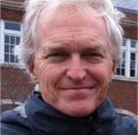](http://www.starvingthebeast.net/home/directorheadshot-75/)**

**INTERVIEW SUBJECTS**

|  |  |
| --- | --- |
| **James Carville** | BA, JD Louisiana State University |
| **Jay Schalin** | Pope Center for Higher Education Policy |
| **Frederick M. Hess** | Director of Education Policy Studies, American Enterprise Institute |
| **Gene Nichol** | Boyd Tinsley Distinguished Professor  of Law, University of North Carolina |
| **Peter Flawn, PhD** | President Emeritus, University of Texas  at Austin |
| **Jeff Sandefer** | Businessman/teacher/author  “Seven Breakthrough Solutions for  Higher Education” |
| **Siva Vaidhyanathan, PhD** | Robertson Professor, University of Virginia |
| **Larry Faulkner, PhD** | President Emeritus, University of Texas  at Austin |
| **Ray Bowen, PhD** | President Emeritus, Texas A&M University |
| **Jamie Grunlan, PhD** | Linda & Ralph Schmidt ’68 Professor, Mechanical Engineering, Texas A&M University |
| **Robert May, PhD** | Former Dean, McCombs School of Business, University of Texas at Austin |
| **Reeve Hamilton** | Reporter, The Texas Tribune |
| **Bill Powers** | 28th President, University of Texas |
| **Hunter Rawlings, PhD** | President, American Association of Universities |
| **Rusty Hardin** | Special Counsel, House Transparency in State Agency Operations (Texas) |
| **Wallace Hall** | Regent, University of Texas |
| **George M. Cohen** | Brokaw Professor of Corporate Law,  Chair, Faculty Senate , The University of Virginia |
| **Robert Mann** | Manship Chair in Journalism, Manship School of Mass Communication, Louisiana State University |
| **Grant Petty, PhD** | Chair and Professor of Atmospheric Science, University of Wisconsin-Madison |
| **Noel Radomski, PhD** | Director and Associate Researcher, University of Wisconsin-Madison,  Wisconsin Center for the Advancement of Postsecondary Education |

**[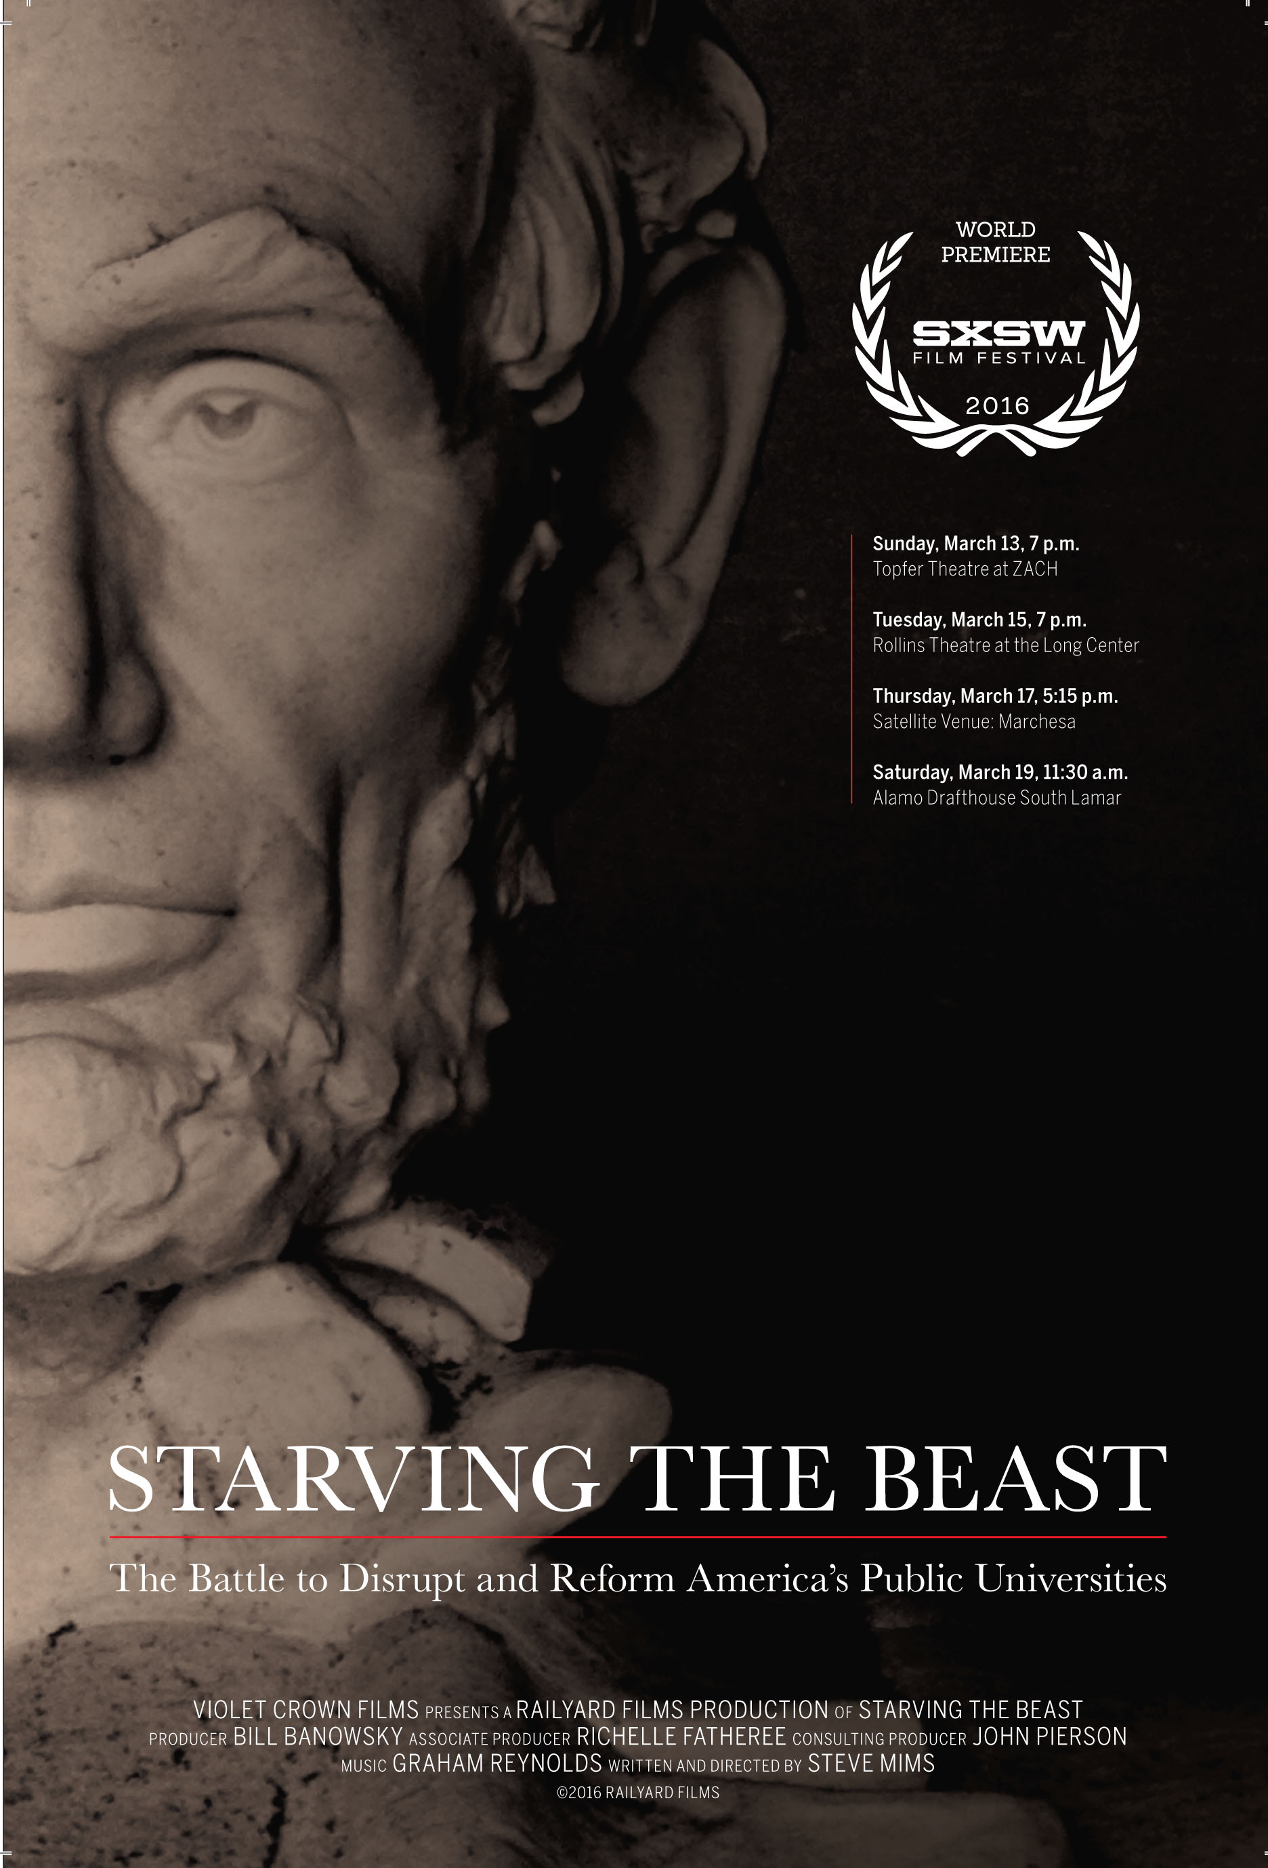](http://www.starvingthebeast.net/beast_postcard_6x9_final/)**

**IMPORTANT DOCUMENTS**

[**“Seven Groundbreaking Solutions”**](http://www.starvingthebeast.net/2008-05-21-HigherEdSummit2-3.pdf)Texas Public Policy Foundation Higher Education Summit, May 21, 2008

[**“The Red and Black Report”**](http://www.starvingthebeast.net/Red%20and%20Black%20Report.xlsx)Academic Financial Data Compilation, September 2010

[**“Investing in Value, Sharing Risk – Financing Higher Education Through Income Share Agreements”**](http://www.starvingthebeast.net/-investing-in-value-sharing-in-risk-financing-higher-education-through-inome-share-agreements_083548906610.pdf)   
American Enterprise Institute, February 2014

[**“Investigative Report to the House Select Committee on Transparency in State Agency Operations regarding Conduct by University of Texas Regent Wallace Hall and Impeachment Under the June 25, 2013 Proclamation”**](http://www.starvingthebeast.net/Investigative-Report-Committee-on-Transparency-in-State-Agency-Operations.pdf)Rusty Hardin & Associates, LLP, March 2014

[**“Postsecondary Education OPPORTUNITY”**](http://www.starvingthebeast.net/Feb%202015%20PSO%20Newsletter-State%20Investment%20and%20Disinvestment%20in%20Higher%20Education%201961%20to%202015.pdf)

The Pell Institute for the Study of Opportunity in Higher Education, February 2015

**ABOUT THE FILMMAKERS**

**Steve Mims – Director / Screenwriter / Cinematographer / Editor**

Steve Mims works as a writer and director in Austin, Texas. His award-winning work includes fiction and non-fiction short and feature-length films, music videos and commercials that have screened internationally in festivals, theatrically and on television.

His documentary INCENDIARY:  THE WILLINGHAM CASE (2011) [co-directed by Joe Bailey, Jr.] won the 2011 SXSW Louis Black Award, the 2012 Innocence Network Journalism Award and the 2013 Texas Coalition to Abolish the Death Penalty Media Award. Ann Hornaday of the Washington Post called INCENDIARY: *“Nonfiction filmmaking at its most classic. Crime, punishment, morality and hardball politics make for an explosive mix all their own.”*

His narrative features include the romantic comedy ARLO & JULIE (2015) which he wrote and directed. ARLO & JULIE premiered at SXSW in 2014 and went on to screen in 16 festivals in the U.S. and Moscow and limited theatrical release. The film won the Trinidad Independent Film Festival’s Gold Award for feature-length comedy. Reviewing the movie, Variety’s Justin Change wrote:  *“...this comic mystery is a low-key, low-budget charmer.”*Steve’s earlier feature comedy, THE PERFECT SPECIMEN, premiered at SXSW and was licensed to SHOWTIME NETWORKS.

Among his short fiction film work, the New York Times called Steve’s movie AUNT HALLIE, *“A treasure...which belongs on everybody’s list of the top-10 funniest nine minute films ever made.”* His short WEBB WILDER, PRIVATE EYE:  THE SAUCER’S REIGN became a late television cult classic on USA Network’s anthology series NIGHTFLIGHT and helped spawn the roots-rock band WEBB WILDER AND THE BEATNECKS. His work has screened at the Museum of Modern Art in New York (Film Society of Lincoln Center, New Directors/New Films) Bilbao, Spain, Hamburg, Germany, St. Petersburg and Moscow. His film awards include the American-Soviet Film Initiative Pick (Ann Arbor Film Festival) the Gold Apple Award (National Educational Film Festival) and the Silver Hugo Award (Chicago International Film Festival). A compilation of three of his shorts (WEBB WILDER’S CORN FLICKS) was release nationally by BMG/Zoo Entertainment. His latest fiction shorts include THE ONE-OFFS, REFLEX, HONORARIUM and WEBB WILDER’S SCATTERGUN.

His short documentary work includes LIVE FOREVER: THE LIFE AND SONGS OF BILLY JOE SHAVER, SOUZAY:  A LIFE IN ART and GOD/MAN/ACCORDION. His short documentary about the fans of the television series Dallas, SOUTHFORK PILGRIMS, was installed as part of an exhibit about the series at the Bob Bullock Texas History Museum. In 2009 Steve won the Barbara Jordan Media Award (director/editor/co-producer) for his short documentary about dyslexia called CHANGING CHILDREN’S LIVES.

His feature-length music documentaries include RUTHIE FOSTER: LIVE AT ANTONE’S, (Blues Foundation Award for Best DVD of 2012) LIZARDS TIMES TWENTY: AUSTIN LOUNGE LIZARDS LIVE AT ANTONE’S and THE AUSTIN LOUNGE LIZARDS:  THIRTY YEARS OF LOST LUGGAGE, all released through Blue Corn Music/ADA/Warner Music Group.

His music videos include work for The Naughty Ones, Pat McLaughlin, Cotton Mather, Webb Wilder, Stephen Bruton, Los Straitjackets, the Austin Lounge Lizards and Billy Joe Shaver. His videos have aired on More Music, TNN, CMT, CMT Europe, M2 and MTV. His video of Billy Joe Shaver’s HOTTEST THING IN TOWN was voted Best Music Video of 1994 by the Austin Chronicle. Television broadcasts include PBS, Italian Public Television, Campus Network, USA Network, Arts & Entertainment Network and The Learning Channel.

Steve also works commercially as a writer, director, producer and editor. His commercial work has won the Bronze Anvil (Public Relations Society of America), district level ‘Addys’, the Citation for Excellence from the American Advertising Foundation and 2013-2014 Bronze Telly Awards.

Steve earned a bachelor’s degree at the University of Southern Mississippi and a Master of Arts at the University of Texas at Austin. Over the years he’s taught film production at UT Austin, including Film One, Film Two and Film Editing. This spring he’s teaching RTF368S:  Undergraduate Thesis Production. Through Austin FilmWorks he also teaches ‘The Film Mind’, a 12-week film design and cinematography course.

His current film is STARVING THE BEAST, a feature length documentary about public higher education that will premiere in 2016 at SXSW.

**Bill Banowsky – Producer**

Bill Banowsky began his career in the film industry in 2001 when he founded Magnolia Pictures, a film exhibition and distribution company. After selling Magnolia Pictures in 2003, Mr. Banowsky served as CEO of Landmark Theatres, the largest chain of art theaters in the country, until 2007. In 2008 Mr. Banowsky founded Carolina Cinemas, a cinema chain with theaters in Asheville, Charlotte and Raleigh, North Carolina. Then, in 2010 Mr. Banowsky started Violet Crown Cinemas, which now has locations in Austin, Texas, Santa Fe, New Mexico, and Charlottesville, Virginia.

Prior to entering the film exhibition industry, Mr. Banowsky practiced commercial real estate and corporate law from 1986-1996. From 1996-2000 Mr. Banowsky served as General Counsel and Executive Vice President of three publicly traded media companies: Capstar Broadcasting; Chancellor Media; and AMFM, Inc. Mr. Banowsky served on the board of directors of LIN Media, a mid-market television broadcasting and media company for 15 years, until its merger with Media General in December 2014.

**Graham Reynolds – Composer**

Austin, Texas based composer-bandleader Graham Reynolds creates, performs, and records music for film, theater, dance, rock clubs and concert halls with collaborators ranging from Richard Linklater to DJ Spooky to the Austin Symphony Orchestra. As bandleader of the jazz-based but far reaching Golden Arm Trio, Reynolds has repeatedly toured the country and released three critically acclaimed albums. As Co-Artistic Director of Golden Hornet Project with Peter Stopschinski, Reynolds has produced more than fifty concerts of world-premier alt-classical music by more than sixty composers, as well as five symphonies, two concertos and countless chamber pieces of his own.

Reynolds music has been heard throughout the world on TV, on stage, in films, and on radio, from HBO to Showtime, Cannes Film Festival to the Kennedy Center, and BBC to NPR. His score to the 2006 Richard Linklater feature *A Scanner Darkly* was named Best Soundtrack of the Decade by *Cinema Retro* magazine. His awards include the Lowe Music Theater Award, four Austin Critic’s Table awards, an Amp Award, five Austin Chronicle Best Composer wins, a B. Iden Payne Award. He has received Meet the Composer and Map grants, as well as support from the National Endowment for the Arts for several projects.

**CREDITS**

Director Steve Mims

Producer Bill Banowsky,

Screenwriter Steve Mims

Cinematographer Steve Mims

Editor Steve Mims

Consulting Producer John Pierson

Associate Producer Richelle Fatheree

Additional Cinematography Holden Fatheree

Assistant Camera Kakii Keenan

Art Director Kakii Keenan

Composer Graham Reynolds

Narrator Brian Ramos

Graphics Mike Nicholson

Post Production Mixer Korey Pereira

© 2016, Railyard Films, LLC. All rights reserved